**Process Discipline**

Admission system

Team Member

|  |  |  |
| --- | --- | --- |
| **Name** | **MSSV** | **Email** |
| Lê Ngọc Châu |  |  |
| Khấu Thành Đạo |  |  |
| Ngô Quang Huy |  |  |
| Nguyễn Phan Xuân Huy |  |  |
| Huỳnh Trọng Khang |  |  |
| Tạ Ngọc Thiên Phú |  |  |

CONTENT

• INTRODUCTION 0

I. PURPOSE OF THIS DOCUMENT 0

II. READER 0

III. SCOPE 0

• SCRUM-MODEL 1

❖ The Original Scrum model Overview 1

❖ Scrum Optimize (integrate with ACDM) 1

• PROCESS DISCIPLINE 2

1. Planning Discipline 2

2. Requirement Discipline 3

3. Architecture Design Discipline 4

4. Code discipline 4

5. Test Discipline 6

History Version

|  |  |  |  |  |
| --- | --- | --- | --- | --- |
| **No.** | **Date** | **Version** | **Content** | **Author by** |
| 01 | 08/11/2013 | 0.1 | Create Input, Output table | Huy Ngo |
| 02 | 19/12/2013 | 0.2 | Update document | Huy Ngo |
| 03 | 25/03/2014 | 1.1 | Change in Test phase | Huy Ngo |
|  |  |  |  |  |

# INTRODUCTION

## PURPOSE OF THIS DOCUMENT

* The purpose of this document is to describe how we apply V-Model into Accounting Project, this part will focus on how we implement every phase, how we control quality assurance…
* What the V-Model look like after we have modified it and the reason why we must modify V-Model to fix with my project.

## READER

* This document was written for the mentors, Accounting Team members to help them have a general vision to conduct this project.
* Besides, this document is a tool to evaluate the project quality. So, this also used to the Committee in the final presentation.

## SCOPE

* We just have a general vision for every discipline are used in the Accounting Project. To understand more, please read more in detail in the specific document refer to the final document.

# SCRUM-MODEL

## The Original Scrum model Overview

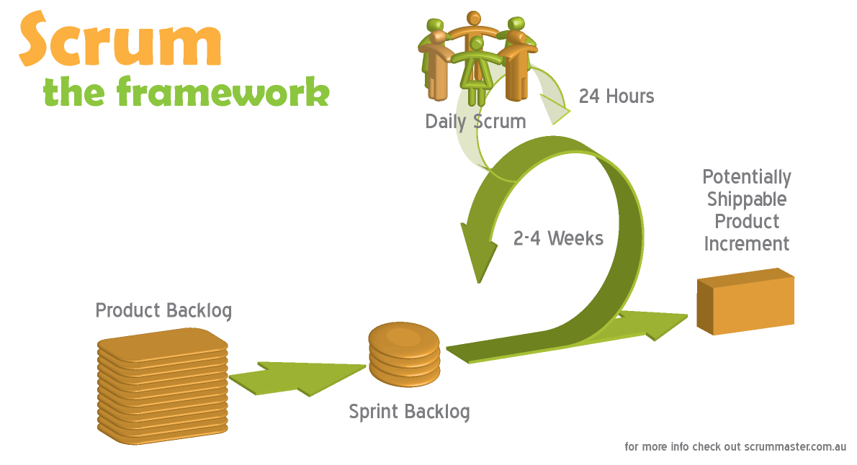

## Scrum Optimize (integrate with ACDM)



# PROCESS DISCIPLINE

## Planning Discipline



|  |  |  |  |  |
| --- | --- | --- | --- | --- |
| **Phase** | **Input** | **Output** | **Lead** | **Responsibility Description** |
| Planning | Project initial | Project management documents | Huy Ngo | * Assign each parts of Software Requirement Specification document to team members and works with team members. * Track progress * Track change version * Summary document. * Log Team Member’s mission. |

## Requirement Discipline



|  |  |  |  |  |
| --- | --- | --- | --- | --- |
| **Phase** | **Input** | **Output** | **Lead** | **Responsibility Description** |
| Requirement Analysis | General Requirement from Customer | Software Requirement Specification | Khang Huynh | * Create ADS outline. * Assign each parts of Software Requirement Specification document to team members and works with team members. * Track progress * Track change version * Summary document. * Log Team Member’s mission. |

## Architecture Design Discipline



|  |  |  |  |  |
| --- | --- | --- | --- | --- |
| **Phase** | **Input** | **Output** | **Lead** | **Responsibility Description** |
| Architecture Design and Module Design | Software Requirement Specification | Software Architectural Design | Phu Ta | * Assign each parts of Software Architectural Design document to team members and works with team members. * Track progress * Track change version * Summary document. * Log Team Member’s mission. |

1. Code discipline



|  |  |  |  |  |
| --- | --- | --- | --- | --- |
| **Phase** | **Input** | **Output** | **Lead** | **Responsibility Description** |
| Coding | Software Architectural Design | Sprint backlog | Dao Khau | * Create Code standard outline. * Assign each parts of Software Requirement Specification document to team members and works with team members. * Track progress. |

## Test Discipline



|  |  |  |  |  |
| --- | --- | --- | --- | --- |
| **Phase** | **Input** | **Output** | **Lead** | **Responsibility Description** |
| Test | 1. Software Requirement Specification 2. Software Architecture Design 3. Source code | 1. Test Plan 2. Test Case 3. Test Report 4. Sprint backlog | Phuoc Nguyen | * Create documents outline. * Assign works to team members and works with team members. * Track progress * Track change version * Summary document. * Log Team Member’s mission. |